Commonwealth of Pennsylvania

Submitted By: Stephanie McCarter, MD Point, TX on 10/10/18

I am a internal medicine physician who also practices environmental medicine and have seen a rapidly growing number of people becoming electrically sensitive especially with the deployment of smart meters. I am submitting this statement because my extreme concern for our population’s health as the amount of exposure to wireless radiation is causing many people to lose their jobs and ability to live a normal life. The FCC has not updated the exposure standards since 1996 and currently there is three times more published data from independent scientists world wide on the harm of wireless radiation than on its safety

Statement in Support of:

- HB 1564 Consumer Opt Out of Smart Meter Usage.

Introduced once more to the PA Legislature by Representative Mike Reese in the 2017-2018 Legislative Session. During the 2015-2016 Legislative Session, this Bill was introduced as House Bill 394.

HB 1564 was introduced by Rep. Reese on June 16, 2017, along with companion bills HB 1565 and HB 1566. Rep. Reese stated: “Many electricity customers throughout Pennsylvania have expressed their desire to not have smart meter technology at their homes or businesses. Their concerns range from securing sensitive and personal information to the health impacts of radio frequency (RF) waves. My perspective is one that questions if a government mandate was appropriate at all.”

These bills were referred to the PA House of Representatives Consumer Affairs Committee, where Chairman Godshall continues to refuse to allow the Bills out of Committee. (See Exhibit “A” for a copy of HB 1564, HB 1565 and HB 1566.)

- SB 441 Smart Meter Technology Bill, which allows consumers to Opt Out of Smart Meters on their property.

Senator Donald C. White reintroduced Senate Bills 364, 365, and 366 from last session to address consumer concerns related to smart meter technology. Those bills were renamed SB 441, 442 and 443, and referred to the Senate Consumer Affairs and Professional Licensure Committee on February 17, 2017, where they have sat ever since. They appear to be identical to the House Bills cited above (See Exhibit “B” for a copy of SB 441, 442 and 443.)

Submitted To: Pennsylvania House Consumer Affairs Committee:

Chair: Robert Godshall; Democratic Chair: Thomas Caltagirone; Warren Kampf, Secretary.
Majority Members: Charlton Alexander; Gene DiGirolamo; Brian Ellis; Joe Emrick; Frank Farry; Rob Kauffman; Ryan Mackenzie; Carl Metzgar; Carl Walker; Eric Nelson; Tina Pickett; Thomas Quigley; Mike Reese; Todd Stephens; Martina White.

Minority Members: Ryan Bizzarro; Frank Burns; Margo Davidson; Tina Davis; Marty Flynn; Anita Astornio Kulik; Robert Matzie; Ed Neilson; Peter Schweyer; Pam Snyder.

HB 1564 Sponsor and Co-Sponsors:

Mike Reese; R. Boback; R. Brown; V. Brown; Dunbar; Emrick; Gabler; Gillen; Grove; A. Harris; Phillips-Hill; Kauffman; Lawrence; Metcalfe; Metzgar; B. Miller; B. O'Neill; Ortitay; Petrarca; Pickett; Readshaw; Rothman; Saccone; Sonney: Staats; Walsh; Ward; Warner; Maloney; Diamond; Wentling; Zimmerman; Helm; Cox; Rapp; Gainey; Roe; Nelson; C. Quinn; Corr; Simmons; Jozwiak; Roae.

Pennsylvania Senate Consumer Protection and Professional Licensure Committee Members:
Chair: Robert Tomlinson: Minority Chair: Lisa Boscola.

Majority Members: Mario Scavello; Vice Chair Joseph Scarnati, III; Ex-Officio; Lisa Baker; Camera Bartolotta; John Gordner; Stewart Greenleaf; Thomas Killion; John Rafferty, Jr.; Mike Regan.

Minority Members: Lawrence Farnese, Jr; Wayne Fontana; Art Haywood; John Yudichak.

SB 441 Sponsors and Co-Sponsors: White; Folmer; Vulakovich; Alloway; Vogel; Ward: Hutchinson; Wagner: Baker, Martin.

Pennsylvania House of Representatives.

Pennsylvania Department of Public Health and Human Services.

Pennsylvania Public Utility Commissioners and PA PUC Legislative Affairs Committee.

U.S. Senator Bob Casey and U.S. Senator Pat Toomey.

Pennsylvania Attorney General Shapiro.

Pennsylvania Governor Wolf.

Dear Esteemed Senators, Legislators and Public Servants,

Thank you for your careful consideration of the above Pennsylvania smart meter bills which will permit opt outs from smart metering on the homes of those Pennsylvania citizens who are negatively affected by smart meter emissions.

As elected officials and public servants, it is your duty to protect all of those you serve, especially your most vulnerable citizens.

There is a small portion of those citizens who are negatively affected by the electromagnetic energy emitted by smart meters. For example, people with electromagnetic sensitivity respond to smart meters with just as extreme reactions as people who have allergic reactions to particular foods or medicines. It is life threatening. The Pennsylvania electric companies, with full backing of the Pennsylvania Public Utility Commission (PUC), and Rep. Robert Godshall are insisting that Act 129 requires them to install smart meters on everyone’s property in the Commonwealth, regardless of customers’ medical conditions. See Appendix I: 2018 letter from counsel to the Pennsylvania PUC, and Rep. Robert Godshall 2015 letter to the Pennsylvania PUC regarding the case of Susan Kreider.

We are aware that many don’t understand the desperate need of some vulnerable Pennsylvanians to have safe analog metering on their private residences; however, in case after case brought to the Pennsylvania PUC, doctors and scientists have confirmed that there are some individuals who suffer negative health effects as a result of smart meters on their homes. (See examples in Appendix II).

They have talked with their electric distribution companies, asking for the reasonable accommodation of using analog meters instead of smart meters on their homes. The utilities have refused, telling them-- many of whom are seniors-- that they must do without electricity, even in 90 degree weather, if they don’t accept a smart meter on their property.

The sickest of them have been forced to file formal complaints with the Pennsylvania PUC. Every single case these Pennsylvanians have brought has been dismissed by the PUC administrative law judges and by the PUC itself.

This is unlike all other states in the United States.

In every state where the issue of alternatives to smart metering has been considered, each and every state except Pennsylvania has allowed for opt-outs. (see Appendix III: 50 State Smart Meter Opt out Chart).

Offering opt outs from smart metering in all the other states has resulted in no detriment to any utility. The smart grid is completely intact. No utility company has lost revenue by offering opt outs--even in Maine, where thousands of customers have opted out of smart meter deployment. (see Appendix IV, Opinion of Maine PUC Commissioner Littell, December 19, 2014, Order re Dockets no. 2011-00262 and 2012-00412). In Vermont, where statewide no fee opt outs have been in effect since 2013, Green Mountain Power is obviously thriving (see Appendix V: 30 Vermont Stat. Ann. §2811).

We are now reaching out to you. Appendix III, 50 State Smart Meter Opt Out Chart --spells out utility regulation and state law authority for myriads of regulations dealing with smart meter opt outs.

At a minimum, we are urging that a bill such as recently promulgated regulations by the State of North Carolina PUC, that allow customers with a medical condition documented by a licensed physician to opt out of smart meters with no fee, should be enacted. (See Appendix VI, North Carolina PUC Regulation 6/22/2018; NC Utilities Comm Order Docket No. E-7, SUB 1115; Docket No. E-100, SUB 147; Docket No. E-100, SUB 153.)

You may, if you have the time, wish to look at the following links:

Michigan Senator Patrick Colbeck testimony on smart meter choice amendments:
https://www.ehs.group/SenatorColbeck.php
Erica Mallery-Blythe, MD, addressing London medical conference on children’s cancer, September 13, 2018, discussing recent research on the effects, including EHS and cancer, caused by non-ionizing radiation such as that emitted by smart meters:

https://www.youtube.com/watch?v=tRbE4CvKA4Q&feature=youtu.be&t=7h8m15s

Thank you for your time and consideration, please contact me if I can provide additional information on this vital issue for medically vulnerable Pennsylvanians.

For a quick link to all Appendices in this Petition, please click here; https://www.ehs.group/Documents/Appendices/Appendices-list.php?rediectApp5=1

Respectfully,

Stephanie McCarter, MD
2755 RS County Road 1490
Point, TX 75472

EXHIBIT “A”

Pennsylvania HB 1564, HB 1565 and HB 1566

https://www.ehs.group/Documents/Exhibits/A/Exhibits-A-list.php

_____________________________________________________________________________________________

EXHIBIT “B”

Pennsylvania SB 441, SB 442, and SB 443

https://www.ehs.group/Documents/Exhibits/B/Exhibits-B-list.php

______________________________________________________________________________________________

For a quick link to all Appendices in this Petition, please click here; https://www.ehs.group/Documents/Appendices/Appendices-list.php?rediectApp5=1

APPENDIX I

https://www.ehs.group/Documents/Appendices/Appendices-list.php?redirectApp1=1
https://www.ehs.group/Documents/Appendices/Appendices-list.php?redirectApp1_2=1

  - April 20, 2018 Letter from Rhonda Davidson, Esquire, Counsel to the PA PUC, to two Kutztown residents who were forced to file a formal complaint against their utility in PUC court (case number C-2018-3000137). This letter from counsel to the PUC, coupled with Rep. Godshall’s October 7, 2015 letter, below, state in effect, that any opt out from smart meter deployment must come from the Commonwealth Court or the State Legislature, because the PUC has interpreted Act 129 as mandating smart meter deployment on every customer’s property (regardless of medical condition.)

Interestingly enough, the legislative history of Act 129, including early comments from Rep Godshall, make it clear that the Senate version of the PA smart meter bill (which was adopted by the House in the final version of HB 2200) was a smart meter opt in only bill (except for new construction). This version of HB 2200 became Act 129 when signed into law by Governor Rendell in 2008. It was the PA PUC implementing regulations which decided that Act 129 wording: “according to a depreciation schedule….” meant that smart meter deployment must be universal, including for all PA utility customers who have medical disabilities.

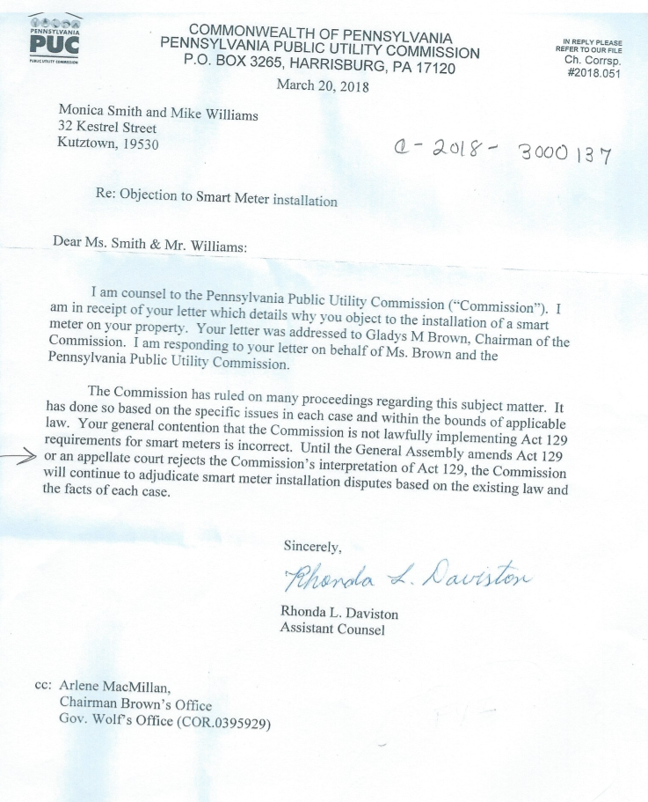

____________________________________________________________________________________________ APPENDIX I continued

  - October 7, 2015 Letter from Representative Godshall to the PA PUC objecting to Susan Kreider being granted a hearing on how PECO’s smart meter caused her to become ill, because there is no opt out from smart meter deployment in Pennsylvania, even if there are negative health effects to individuals.

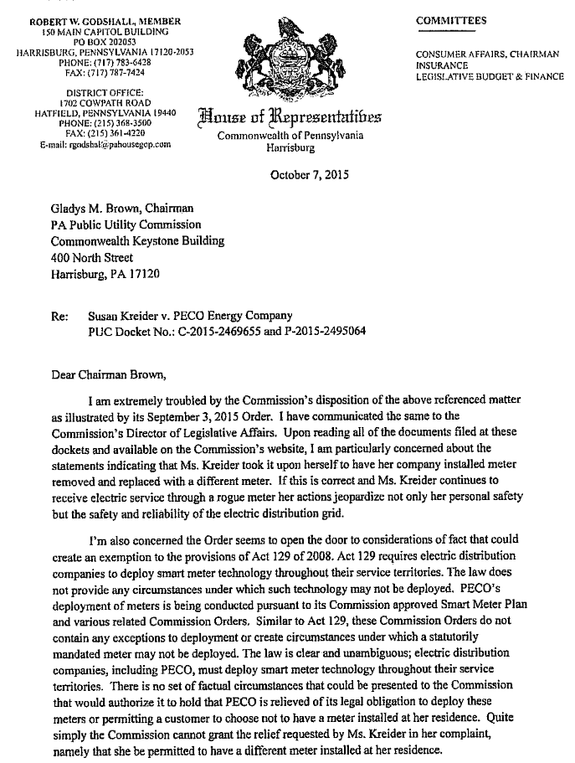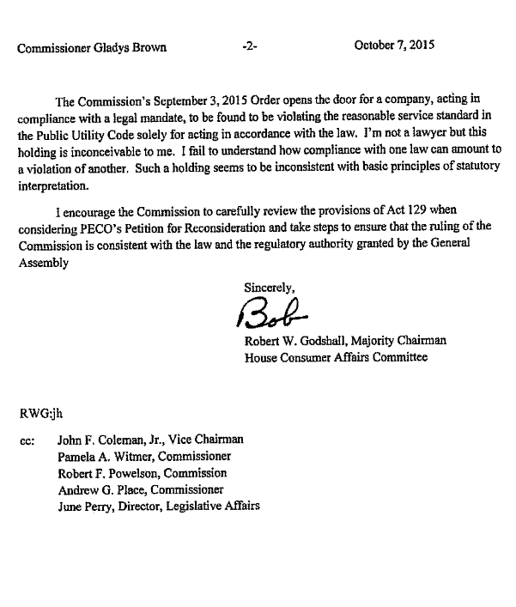

________________________________________________________________________________________________

APPENDIX II

Summaries of just eight histories of smart meter harm cases brought before the PA PUC by affected Pennsylvanians.

- Susan Kreider, a disabled nurse from Germantown, PA, Philadelphia County, brought a formal complaint against PECO (PUC case numbers C- 2015-2469655 and P-2015-2495064) because the PECO smart meter on her home had caused her a great deal of harm, and PECO refused to accommodate her disability by removing it. She hired a lawyer to ask for an accommodation of an analog meter. PECO refused. She hired an electrician to replace the smart meter with a calibrated analog meter that she purchased on line. She went through a full blown hearing pro se, testifying that she had lost many days of work, had a great deal of trouble sleeping, developed heart issues, became temporarily deaf, hobbled on her crutches to sleep in the farthest place from the smart meter, and she developed other troubling symptoms when the PECO smart meter was on her home. Although Administrative Law Judges Heep and Pell ruled that Susan Kreider had presented a prima facie case that the smart meter had harmed her, Heep and Pell ruled that the testimony of PECO expert witnesses, stating that the smart meters cannot harm anyone, outweighed Susan’s own testimony that she, in fact, suffered from electrohypersensitivity (EHS), and she was harmed by the PECO smart meter. See attached opinion of Heep and Pell of September 22, 2016, dismissing Ms. Kreider’s complaint after a full hearing. Susan appealed the decision, but she died before the PUC ruled in her case. Susan was hospitalized for unrelated causes in October 2016, and she quickly developed high blood pressure resulting in her first stroke.

Hospitals and nursing homes are especially difficult environments for those with EHS to endure, because of the large volume of microwaves there which patients cannot escape. Continued exposure can lead to strokes and death, which is what happened in Susan’s case. She never returned home.

After suffering a second stroke in a few weeks’ time, while still in the hospital and nursing home environments, she was taken off life support and died.

- Dr. and Mrs. Van Schoyck of Bucks County, PA, were suffering effects from the PECO smart meter, which caused light bulbs to burst in their house and caused them severe health effects, consistent with EHS symptoms. They filed a formal complaint against PECO and hired a lawyer to represent them, listed at Docket No. C-2015-2478239. They decided to go off grid rather than to continue to take their chances that the PUC would rule in their favor and allow them to keep the analog meter which they had purchased on line. The analog meter alleviated most of their EHS symptoms caused by the PECO smart meter. They borrowed a great deal of money to take their property off grid in a safe manner for those who suffer from EHS. They closed their case with the PUC after they were forced to go off grid completely rather than suffer from a smart meter on their home again.

- A.S. of Lancaster County, PA, is an erudite Pennsylvania resident in his 70s. He has authored a book on healing which has been translated into five different languages. A.S. is senior editor of one of the world’s largest medical websites. He has suffered from EHS for many decades. He was compelled to buy an EMF shielded computer 30 years ago because of his EHS. He uses no wireless technology in his home because of his EHS. His EHS prevents him from sleeping at all for days on end, causes him extreme mental confusion and digestive and related health effects. He was forced to sue PPL in PUC court, case number C-2017-2621285, because he is negatively affected by the smart meter PPL placed on the wall his neighbor shares with his home. PPL threatened to shut off his electricity if he did not accept a smart meter on his meter socket, too. Despite (1) submitting three internationally recognized physicians’ notes and (2) a nationally recognized medical practitioner’s testimony, and despite (3) authenticating world famous expert testimony on EHS, and (4) the testimony of an electrical engineer with 40 years’ experience who performed actual measurements of the microwave (RF) radiation and conducted emissions of smart meters, PUC ALJ Elizabeth Barnes dismissed A.S.’s complaint, stating that the PPL expert testimony that PPL’s smart meters could not cause any ill effects in anyone, outweighed A.S.’s testimony, the testimony of his treating physicians, that of his electrical engineer expert and all the other cited expert testimony. See attached opinion of ALJ Barnes, dated August 16, 2018. This opinion opens the door for PPL to attach a smart meter on A.S.’s home, which will inevitably lead to severe health consequences for A.S., if there is no opt out from smart meter deployment for him.

- M.P., a retired professional in Chester County, was forced to file a formal complaint against PECO in 2015 after PECO sent her a 10-day shut-off notice because she refused to allow a contractor hired by PECO to install a smart meter on her home. (See PUC case no. C-2015-2475355.)

After moving to Pennsylvania in 2002, MP developed certain health issues that her treating physician suspected had been caused by the AMR meter that came with her new-construction home, unbeknownst to M.P. M.P. does not use any wireless devices in her home because of her sensitivities to them. Once PECO had completed installation of three smart meters (electric, gas and water) on every home in her neighborhood except hers, in 2014, M.P. began to suffer more pronounced symptoms of EHS (electro-hypersensitivity) than before – insomnia, nervousness, brain fog, confusion, fatigue, pain and muscle weakness, chest discomfort with heart palpitations, and memory loss. As a result, M.P. rarely leaves her home, and can no longer lead a normal life.

M.P. went through a full smart meter accommodation hearing in PUC court in November 2016, where she and her physician, who specialized in treating EHS patients, both testified that she was disabled with EHS and could not tolerate a smart meter. PUC ALJ Heep dismissed her complaint, stating that the expert witnesses for PECO, (an electrical engineer and a pediatric oncologist), who had never even met M.P., presented more credible testimony than M.P. and her physician as to her disabilities and need for an analog meter on her home.

It should be noted that the two PECO expert witnesses had been brought in by a D.C. law firm, whose two partners specialize in representing utilities against allegations of harm. These two D.C. lawyers were hired to assist PECO and other PA utilities in their smart meter hearings, by bringing in the same two wireless industry focused individuals to testify in all customer smart meter harm hearings, that smart meters cannot harm anyone. It should be also noted that the PECO hired pediatrician expert had never seen or treated a patient with EHS. He disagreed with M.P. and her physician, and continues to disagree with all the personal physicians and expert witnesses who have testified on behalf of all other Pennsylvania residents who suffer from EHS and other disabilities. The testimonies of all those personal physicians and expert witnesses stated categorically that EHS is a condition where physical manifestations appear in the bodies of affected individuals, much like severe allergies, caused by physical electromagnetic forces absorbed by the body. In contrast, the industry hired pediatrician, in every single EHS case brought before the PA PUC has testified that EHS is a purely imaginary psychological syndrome. (He based this conclusion solely on a flawed UK study funded in large part by the UK mobile telecommunications industry.)

The PUC Commissioners dismissed M.P.’s case on June 14, 2018. Five days later, PECO installers appeared on M.P.’s property at 8:30 A.M., and told her they were there to install a smart electric meter because the PUC had dismissed her complaint. Even though MP told the PECO installers that she was in the process of appealing that decision (which she did-- see attached motion for reconsideration), and even though the installers contacted PECO’s legal department to convey that information, the PECO installers were directed by PECO legal department to call the police to her front lawn to aid in a forced installation of a smart meter on MP's home. Because of her extreme sensitivity to microwaves, M.P. continues to be severely impaired as long as the PECO smart meter remains on her home - the one place where she should expect to be safe.

- Dr. A.M., an internationally known veterinary radiologist in Delaware County who works from home. She was in excellent health before she developed EHS. She suffered a cardiac arrhythmia and had marked exacerbations of other EHS symptoms when PECO put a smart meter on her home in November 2015. Her cardiac arrhythmia resolved each time PECO removed the smart meter from her home, but many of her EHS symptoms such as headaches and pain have persisted when she is exposed to electromagnetic fields, despite the many interventions she has pursued. She can no longer tolerate any wireless devices in her home. International travel for business and lecturing at conferences, which had been regular occurrences before PECO attached a smart meter on her home has been limited. She can no longer attend church or many other public activities with her family outside her electromagnetically quiet home due to this hypersensitivity and the ubiquity of EMF’s in the environment. Now, even taking her children to athletic events and school functions causes Dr. A.M. to suffer from headaches and pain. Dr. A.M. was forced to sue PECO in PUC court when PECO told her they would deploy a third smart meter on her home in 2017; see PUC case no. C-2017-2621057. She and her physician husband pursued a four day hearing. Three physicians testified that electromagnetic fields caused her EHS symptoms, and that the smart meter was specifically causal to Dr. A.M.’s cardiac arrhythmia. An independent well respected electrical engineer with a national reputation, who measured various electromagnetic fields from PECO smart meters also testified for her, refuting the PECO expert testimony regarding the PECO smart meter emissions. Dr. A.M.’s case is still pending a decision from PUC ALJ Judge Heep, but Judge Heep already ruled, contrary to all Pennsylvania law on the subject, that PECO was permitted months after the fact, to admit ex post facto two DC lawyers to the PA Bar to represent PECO in this case, and in other PECO smart meter harm cases.

These DC lawyers participated a great deal in these hearings to present testimony of PECO expert witnesses. They also cross examined the complainants’ witnesses. ALJ Heep admitted these two DC lawyers to the PA Bar, on PECO’s motion, months after the hearings, and months after all testimony had concluded, and months after final transcripts had been received, and after all briefs had been submitted. Judge Heep has already ruled against every single PA disabled customer who brought a case of smart meter harm to her courtroom. So, it is likely that Judge Heep will dismiss Dr. A.M.’s complaint, and the PA PUC will follow suit, despite all the evidence that has been presented of harm to disabled customers caused by smart meter deployment on their homes.
- Dr. L.M., an elderly Chester County resident, who had been a practicing lawyer in Pennsylvania and Delaware for over 25 years, suffers from a genetic syndrome and head trauma which resulted in her becoming extremely electromagnetically sensitive. Dr. L.M. was forced to file a formal complaint in PUC court against PECO in 2015, after PECO sent her a 10 day shut off notice because she refused to allow PECO to install a smart on her home. Dr. L.M. and her husband have lived on their farm in Chester County since 1990. They and their animals rely on well water, pumped into their home and barn with electricity. There is no public water source. There are no gas lines in her area for alternative fuel. See PUC case number C-2015-2475726. Dr. L.M. hired two attorneys to represent her, and two world famous expert witnesses to testify on her behalf for more than 7 days of testimony. Her physician testified as to her EHS symptoms, and how the PECO AMR first generation smart meter caused her to suffer severe health consequences, causing heart arrythmias, insomnia, extreme fatigue, mental confusion, endocrine disorders, detached retinas, agitation, joint pain, severe digestive disturbances (necessitating a colon resection), and other symptoms. Dr. L.M. testified about the measures she has had to take since her automobile accident to protect herself from microwave exposure inside her home, including eliminating all wireless devices in the house, protecting her house with shielding paint from being bombarded with microwaves from the new PECO tower gateway basestation and having an electrician remove the AMR meter that PECO had installed on her home in 2002, and replace it with a recalibrated analog meter which she had purchased. Despite ALJ Heep’s interlocutory ruling in a separate ADA motion, stating that L.M. was far safer in her house than in any PUC hearing room because of the measures she had taken to remove all wireless emitting devices in her home, (see attached ALJ Heep and Pell September 9, 2016 interim order on ADA motion), nevertheless, ALJ Heep issued an order on March 20, 2018 disposing of the whole of Dr. L.M.’s case, dismissing it, stating that (1) Dr. L.M. was already sick; (2) PECO expert testimony was persuasive that the smart meter could not harm anyone, (2) EHS was a mental disease, not a physcal disease, and (3) the PECO expert testimony outweighed the testimony of Dr. L.M., her personal physician, and two world experts in the field of electromagnetic energy and the harm it can cause sensitive individuals. (See ALJ Heep order dated March 20, 2018). Judge Heep has opened the door for PECO to slap a smart meter on her home as PECO did to M.P., which would leave Dr. L.M. with no safe haven to rest and recuperate in.
Dr. L.M. has filed exceptions to this order. The PUC has not yet ruled on her case, but if the PUC follows its earlier path, it will rule that Dr. L.M. is not entitled to an accommodation, despite her medical conditions, from smart meter deployment on her property.
- Dr. C.R., a chemist who lives in Roxborough, PA, Philadelphia County, has survived three different types of cancer. She is genetically predisposed to develop cancer. She and her husband do not have any wireless devices in the house because of their health concerns. Dr. C.R. was forced to file a formal complaint against PECO because PECO refused to grant her the accommodation she requested to not install a smart meter, and she was concerned about the health effects of the smart meter. Even before filing the formal complaint, she and her husband hired an attorney to represent them. See PUC docket number C-2016-2537666. C.R. testified about her genetic predisposition to develop cancers and her cancer treatments, her gynecologist testified about her cancers and the need to avoid exposure to microwaves to the extent possible to avoid a recurrence or new cancer, and two world famous experts in the field of electromagnetic energy and its effects on living creatures including humans testified, in PUC hearings that extended for over 7 days, that the PECO smart meters can cause cancer. Nevertheless, ALJ Heep ruled dismissing Dr. C.R.’s formal complaint, stating that (1) Dr. C.R. was already sick; (2) PECO expert testimony was persuasive that the smart meter could not harm anyone, and (3) the PECO expert testimony outweighed the testimony of Dr. C.R., her gynecologist, and two world experts in the field of electromagnetic energy and the harm --including cancer-- that it can cause to sensitive individuals. See ALJ Heep order dated February 21, 2018, issued March 20, 2018.
Dr. C.R. has filed exceptions to this order. The PUC has not yet ruled on her case, but if the PUC follows its earlier path, it will rule that Dr. C.R. is not entitled to an accommodation from smart meter deployment on her property, despite her medical condition, and despite her strict avoidance of all wireless devices in her home.
- M.P., an MBA professional who lives in Bucks County, PA, was forced to file a formal complaint against PECO when PECO sent her a 10 day shut off notice since she objected to a smart meter on her home. See C-2015-2475023. M.P. has no wireless devices in her home. She was extremely healthy until she developed severe EHS symptoms when PECO smart-metered her community. She hired two lawyers to represent her in her case. She testified regarding her severe EHS symptoms which persist to this day; her physician testified as to her EHS, and two world famous expert witnesses, in a joint defense arrangement with two other complainants, testified that EHS exists as a physical syndrome, not a mental syndrome, and that the PECO smart meters can cause severe health effects in vulnerable individuals. M.P. also testified that moving the meter socket away from her home would have little effect, even if moving it were agreeable to the homeoowners association where she lived, because the homes were so close together, barely 10 feet from one another in her development.
Strangely, ALJ Heep ruled that “something” with PECO smart meters caused M.P. to suffer ill effects, but it could not be the microwaves, since the PECO expert testimony outweighed that of M.P. experts, but since there was no opt out from smart meter deployment in the Commonwealth, M.P. could move her meter socket, at her expense, away from her house, and PECO could attach a smart meter on her newly located meter socket. See ALJ Heep order dated January 18, 2018, issued March 20, 2018. M.P. has filed an appeal of this order, which is tantamount to a dismissal of her complaint, because it offers her nothing.
The PUC has not yet finally decided her case. M.P. could have saved all her legal expenses, expert witness fees and aggravation in filing her formal complaint, if moving her meter socket away from her house would have solved her medical issues with PECO’s smart meter deployment. The option of moving the meter socket away from the home at the homeowner’s expense has been available to every single PA resident for many years, pursuant to PA PUC PECO Electric Service Tariff No. 5, Section 3.2 Meter Location, and also under 52 PA Code Section 57.27: Pole removal or relocation charges. This is an expensive endeavor, initially costing several thousands of dollars, up to $10,000, and offers no solution at all for those with EHS, putting aside the microwave issues, because the conducted emissions of the smart meters place harmonics and transients on every single electrical wire in the household. These conducted emissions were measured on Pennsylvania smart metered homes by a nationally famous electrical engineer who testified about them in several disabled customer PA PUC smart meter harm hearings.
There are other concerns with moving the meter socket away from the home, in addition to microwave exposure, the expense of the move, and the conducted emissions issues:
- Certain home locations may make moving meter sockets away from the home infeasible.
- The homeowner must assume complete financial and physical responsibility to maintain all wiring running between the relocated meter socket and the home, a responsibility which many homeowners cannot or do not wish to assume.
- Unless the meter socket is moved at least 35 to 50 feet or more away from the house, the microwaves coming from the meter will not be attenuated enough to accommodate an EHS individual’s sensitivities to microwaves alone.
- Moving the meter socket away from the disabled person’s home will prevent the disabled person from enjoying all of his or her property. The microwave emissions coming to and from the meter will cause a constructive eviction to the disabled homeowner from a large portion of the disabled person’s property.
- Under the federal Americans with Disabilities Act (ADA), the utility is responsible for assuming all costs for reasonable accommodations for the disabled customer. It is against the ADA for the PUC to require disabled customers to assume financial responsibility for reasonable accommodations required for their disabilities.
- There are some elderly sensitive Pennsylvanians who were forced to move out of state to find safe haven in a state with smart meter opt outs. Even after moving the meter socket off their home, when their utility placed a smart meter on that socket, their health deteriorated because of the smart meter’s effects on their household wiring. They had to leave Pennsylvania, because they could not safely tolerate a smart meter on their property.

_____________________________________________________________________________________________________

Appendix III

50 State Smart Meter Opt out Chart

https://www.ehs.group/smart-meter-opt-out-chart.php

________________________________________________________________________________________________
Appendix IV

Opinion of Maine PUC Commissioner Littell, December 19, 2014, Order re Dockets no. 2011-00262 and 2012-00412, starting at page 24.

https://www.ehs.group/Documents/Appendices/Appendices-list.php?redirectApp4=1

______________________________________________________________________________________________

Appendix V

30 Vermont Stat. Ann. §2811

____________________________________________________________________________________________

Appendix VI

North Carolina Utilities Commission, Order Approving Manually Read Meter Rider with Modifications and Requesting Meter-Related Information, Dockets E-7, SUB 1115; E-100, SUB 147; and E-100, SUB 153, June 22, 2018, p 14.

https://www.ehs.group/Documents/Appendices/Appendices-list.php?rediectApp6=1

“While DEC’s [Duke Energy Carolina] smart meter technology meets current FCC standards, the Commission believes it is inappropriate to require customers who maintain that they need to avoid exposure to RF emissions to the extent possible to protect their health to pay DEC’s proposed smart meter opt-out charges. Therefore, the Commission will require DEC to amend its Rider MRM to remove the customer charges for those customers who provide the Company with a notarized statement from a medical physician licensed by the North Carolina Medical Board that the customer must avoid exposure to RF emissions to the extent possible to protect their health. Upon receipt of such statement, the Company shall waive both the one-time and the monthly fees under Rider MRM. The Commission further requires that such medical statements must be handled and processed by the Company in a secure and confidential manner to protect customer privacy.”

North Carolina Utilities Commission, ORDER APPROVING MANUALLY READ METER RIDER
WITH MODIFICATIONS AND REQUESTING METER-RELATED INFORMATION, Dockets E-7,
SUB 1115; E-100, SUB 147; and E-100, SUB 153, June 22, 2018, p 14.

______________________________________________________________________________________________

